1. Click on Deployments.

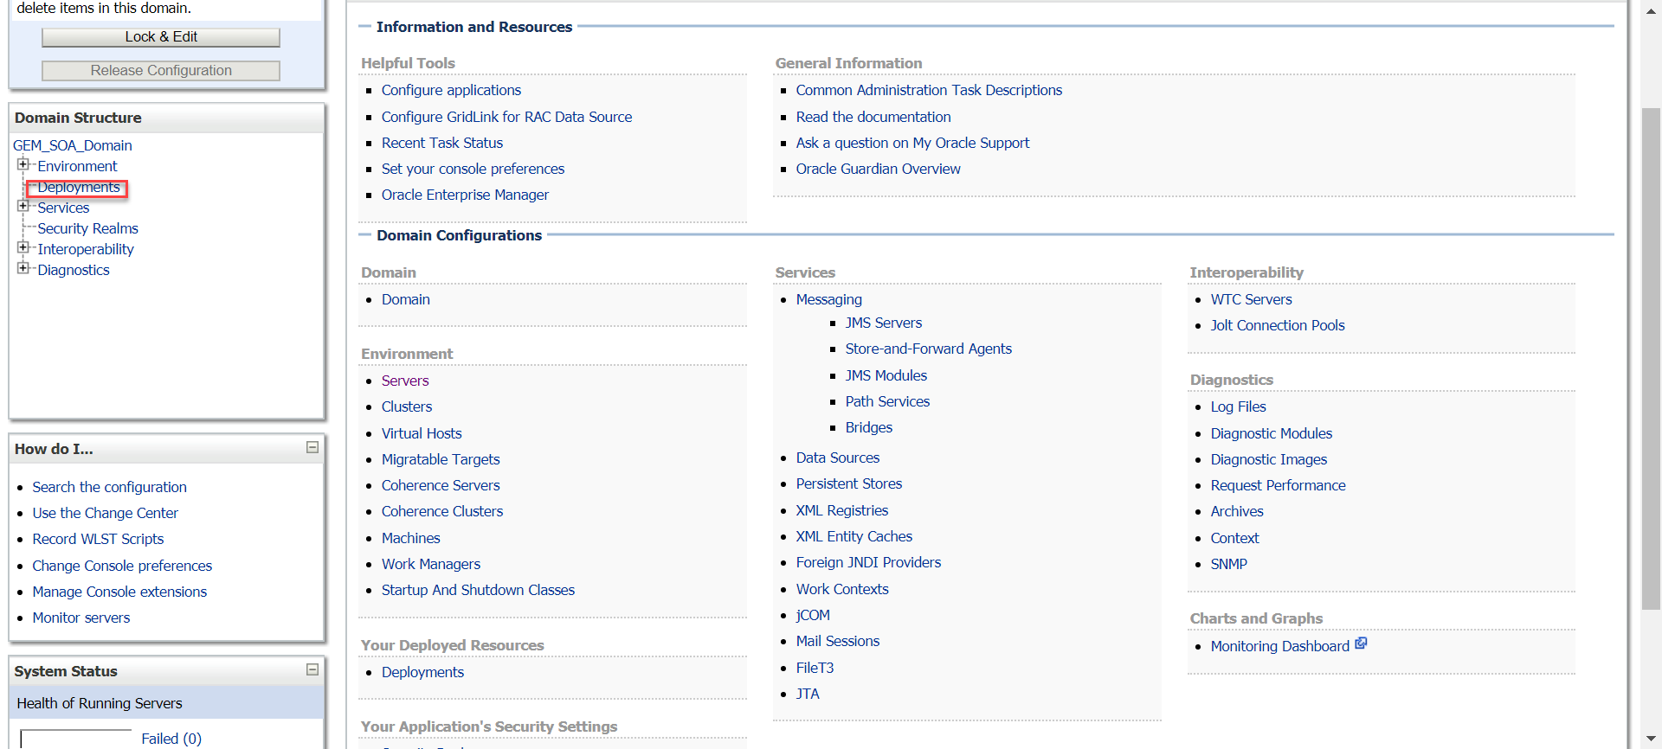

1. Click on FTP Adapter.

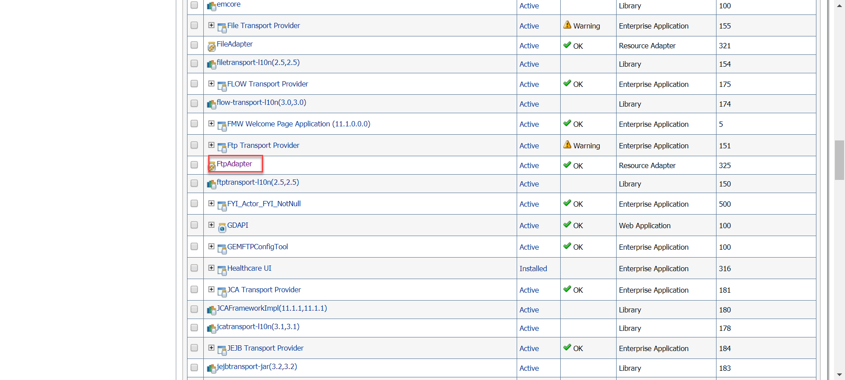

1. Configuration -> Outbound connection pool -> Expand the Connection Factory.

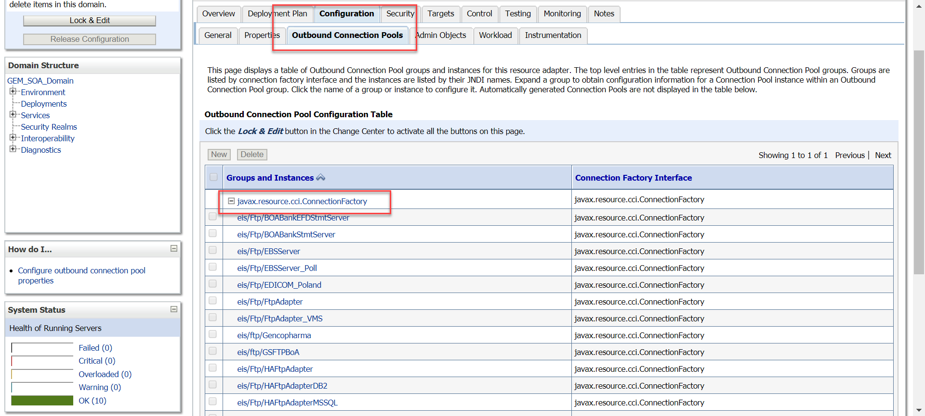

1. Click on EBSserver JNDI and make sure the Username and Password is Visible, capture the Username and password.

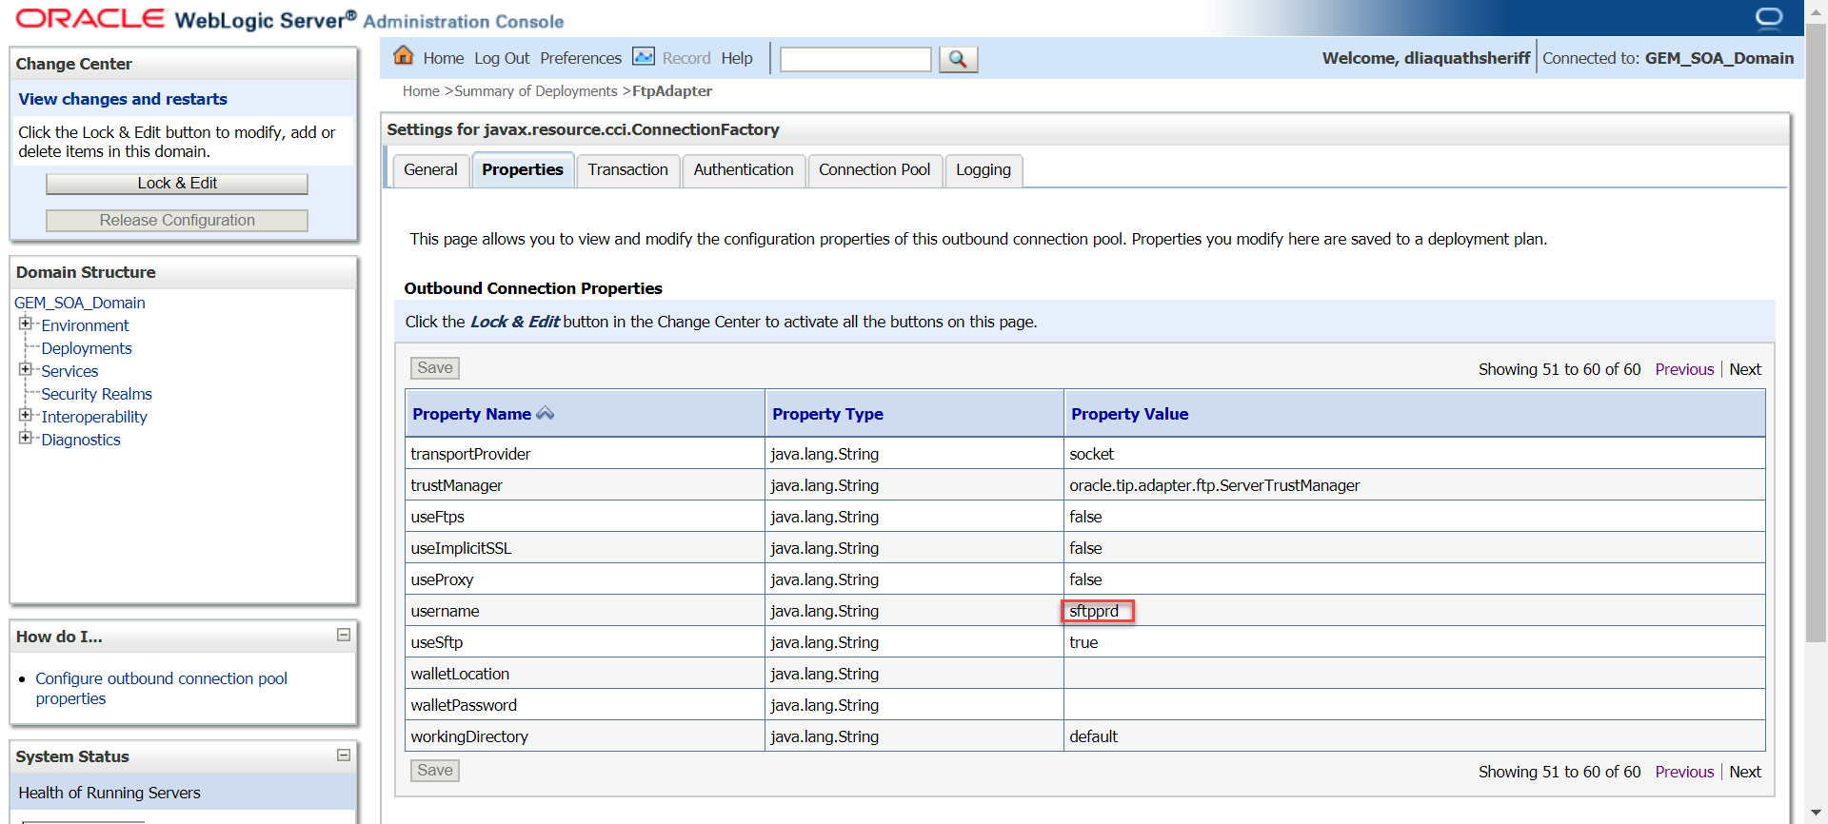

1. Go back to FTP adapter under Deployments again. Click on Security -> Credential Mappings -> New.

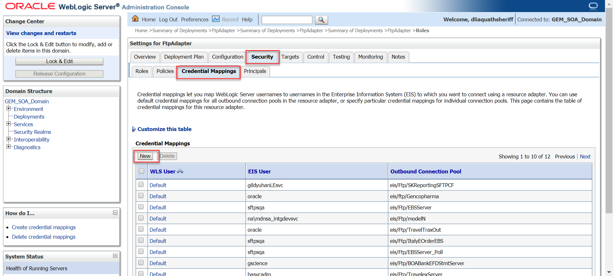

1. Select the JNDI -> Next

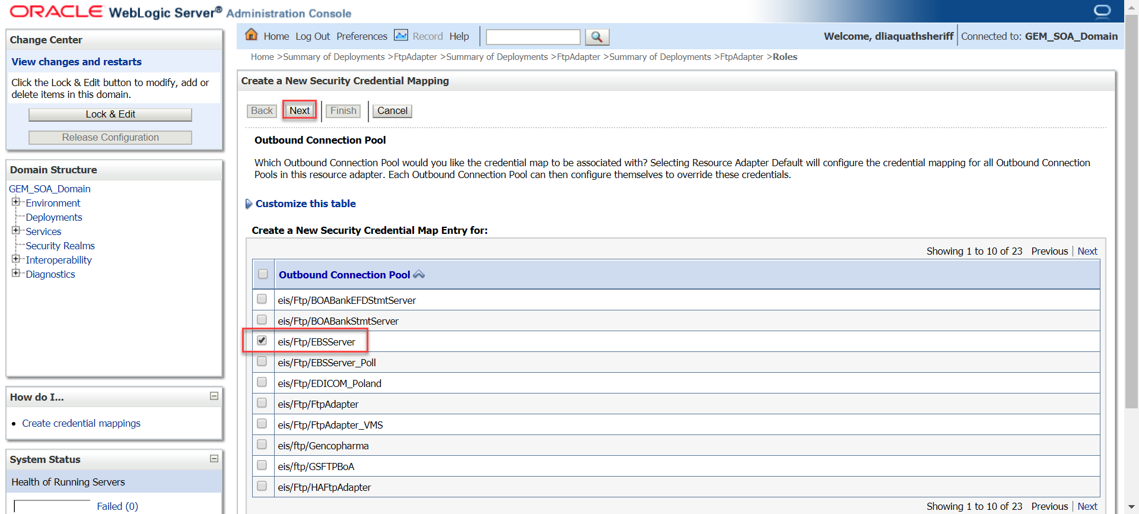

1. Enter Username and password -> Finish.

